Internship

**TestReport**

**Stepper motor**

**Student:** Casper R. Tak

**Studentnumber:** 657313

**Client**: Rudie van den Heuvel

**Coach:** Jeroen Veen

**High School:** HAN Arnhem

**Education:** Embedded Systems Engineering

**Date:** 08-11-2022

Inhoud

Objective 3

Test Setup 3

Test1 Results 4

Conclusions 5

Further actions 5

Test2 Results 6

Conclusions 6

# Objective

The component that will be tested in this test report will be the stepper motor. This component is responsible for moving fluids from point a to point b.

# Test Setup

* Testing equipment:
  + Hardware:
    - Zaleae Logic 16
  + Software:
    - VSC
    - SSH connection to RPI
    - Logic 2.3.45
* Setup hardware/software

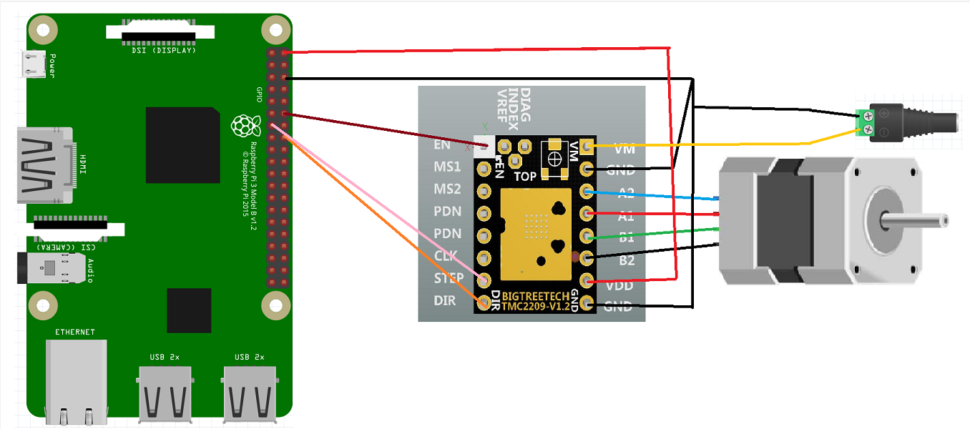

# Test1 Results

|  |  |  |  |  |  |  |
| --- | --- | --- | --- | --- | --- | --- |
| Test | Test passed if: | Observations | Test passed | Test Failed | Pictures | Notes |
| T1.0 | Motor torque increases when enabled | Motor shaft can’t be turned by hand anymore | X |  |  |  |
| T1.1 | Motor Torque decreases when disabled | Motor is stuttering |  | X |  | Motor control seems to be lost, motor cannot be turned off (enable pin is using pwm for some reason.) |
| T2.0 | Motor shaft turns clockwise | Motor is stuttering clockwise and anticlockwise |  | X |  |  |
| T2.1 | Motor shaft turns counterclockwise | Motor is stuttering clockwise and anticlockwise |  | X |  |  |
| T2.2 | Motor steps silently (silent stepping/micro stepping) | clockwise and anticlockwise, makes audible stutter noises |  | X |  |  |

# Conclusions

* The motor is not controlled correctly, something is wrong in either the software, connections (breadboard) or pigpio library, I expect the first.

# Further actions

* I will try to find bugs in the software and strip down the test to enable and disabling the motor only. Ask teacher for help if needed. Then I will do new tests.
* New discoverys: it seems that the DMA controller or maybe a background process from pigpio keeps running the code somehow. By setting the pin as an input it does put the pin on LOW. By putting it back as output (as shown below) the pin becomes high again, so somehow the old program keeps running.
* Changing pins or using write functions doesn’t seem to fix anything. I compared the hardware pwm and software pwm but all seems to be basically the same.

Daemon causes issues. Because when we restart the daemon everything works. Removing the -l doesn’t work.

Solution: we settled on disabling the automatic start of the daemon on boot. I now manually start pigpiod when I run my program, so not at boot.

Check status: systemctl status pigpiod

Stop pigpiod: systemctl stop pigpiod

|  |  |  |  |  |  |  |
| --- | --- | --- | --- | --- | --- | --- |
| Test | Test passed if: | Observations | Test passed | Test Failed | Pictures | Notes |
| T1.0 | Motor torque increases when enabled | Motor shaft can’t be turned by hand anymore | X |  |  |  |
| T1.1 | Motor Torque decreases when disabled | Motor is stuttering | X |  |  |  |
| T2.0 | Motor shaft turns clockwise | Motor shaft turns clockwise | X |  |  |  |
| T2.1 | Motor shaft turns counterclockwise | Motor shaft turns counterclockwise | X |  |  |  |
| T2.2 | Motor steps silently (silent stepping/micro stepping) | Motor turns near silently | X |  |  |  |

# Test2 Results

# Conclusions

* The motor is now running the way it should. It’s resolution could be improved by switching from 1/16 micro stepping to 1/64. To achieve this on the PCB, we need to add resistor pads to ms1, ms2.

# Further Actions

* After some more research it was found that using the UART function of the TMC2209 gives us much more accuracy and control over the data going in and out of the drivers. Redesign V0.3 of the Rastaban Hat will therefor only use UART to control the drivers.